House sitting agreement

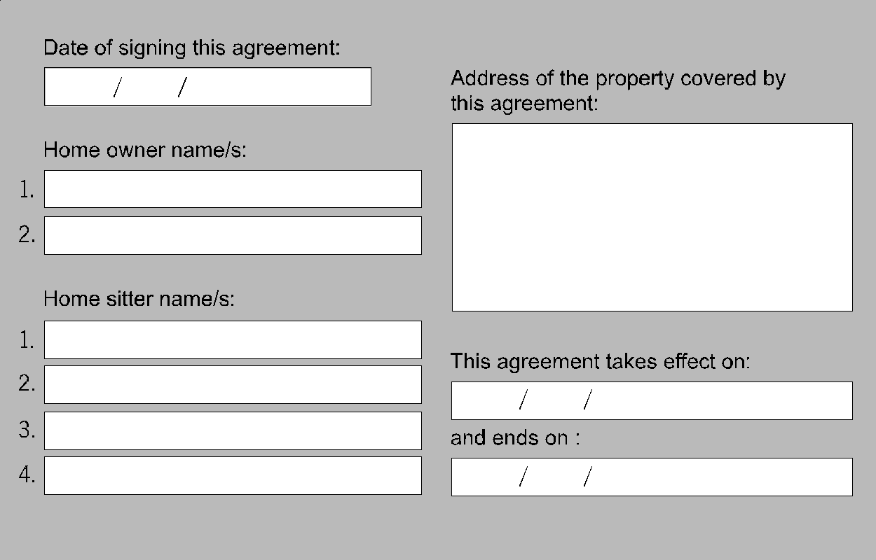

The home owner gives the house sitter permission to occupy the above premises as long as they abide by the conditions of this agreement.
No person/s or pet/s other than those listed in this agreement are permitted to live at the premises during the term of this agreement.
This is not a lease. Both parties agree that the house sitter only has a license to occupy the premises according to the terms and conditions of this agreement and has no legal interest in the premises.
At the end of this term the house sitter may continue to occupy the premises under the same terms of this agreement only if given permission to do so by the home owner.
If the home owner requires the house sitter to make rental payments, then this agreement needs to be adjusted and extended to cover these arrangements.
All parties to this agreement should have their own copy of this agreement, which should be signed by every person who is party to this agreement.

1. Access to the premises

1.1 The home owner agrees:
  - to provide the house sitter with at least seven days notice of any change to the agreed first day of the house sitting assignment
  - to provide the house sitter with seven days notice of an inspection of the premises
  - that the premises will be vacant and in a habitable condition for the house sitter to move in on the agreed first day of the house sitting assignment

The home owner, or any person authorised in writing by the home owner, may only enter the premises during the terms of this agreement in the following circumstances:
  - in an emergency (including to make urgent repairs)
  - if the premises seem to be abandoned
  - for any other purpose, if the house sitter agrees

1.2 The house sitter agrees:
  - to be responsible for any act by any person the house sitter allows on the premises who breaks any terms of the agreement
  - not to sub-let the premises without the home owner’s prior written permission
  - not to allow any person not listed in this agreement to live at the premises without the home owner’s written permission

2. Care of the premises

2.1 The home owner agrees:
  - to ensure that the premises are reasonably clean and fit to live in
  - to provide the house sitter or the home owner’s nominated contact person with a set of spare keys for the premises

2.2 The house sitter agrees:
  - not to use the premises, or allow the premises to be used, for any illegal purpose
  - not to cause a nuisance or allow a nuisance to be caused on the premises
  - not to interfere, or allow others to interfere with the reasonable peace, comfort or privacy of neighbours
  - not to keep any animal on the premises other than those listed in this agreement without the permission of the home owner
  - not to block any sink or drain
  - not to cause or allow any damage to be caused to the premises
  - to care for every item in the premises
  - to regularly clean the bathroom and kitchen
  - to maintain the grounds and garden in the same condition as at the start of this agreement
  - to put all household rubbish and recycling out for regular collection
  - to report any infestation of the premises to the home owner and seek advice for solutions to the problem
  - to keep the premises as clean and tidy as at the start of this agreement
  - to notify the home owner as soon as possible of any damage to the premises
  - to leave the premises as nearly as possible in the same condition (fair wear and tear excepted) as at the start of this agreement
  - to regularly feed, water and maintain any indoor plants and to keep them in at least as good a condition as at the start of this agreement
  - to keep windows and doors locked where appropriate and ensure that any other security measures in the premises are used effectively

3. Care of animals
Name and describe each animal to be covered by this agreement. Describe how you would like each animal to be managed on a day-to-day basis. Include details of any medications or special treatment that each animal requires.

3.1 The home owner agrees:
  - to describe in writing and in detail how any animals normally resident at the premises should be cared for
  - to provide all food and sundry supplies (insect control and other medicine, bedding, exercising and cleaning equipment) for the animals, or make arrangement to reimburse the house sitter for any food or supplies bought for the animals
  - to make arrangements for payment for any services provided by a qualified veterinarian in the treatment and care of the home owner’s animals

3.2 The house sitter agrees:
  - to make every reasonable effort to ensure the good health, comfort, safety and happiness of the animals listed in this agreement
  - to follow the home owner’s instructions as far as possible in the care of the animals listed in this agreement

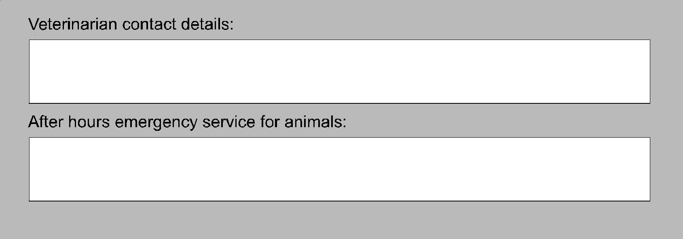
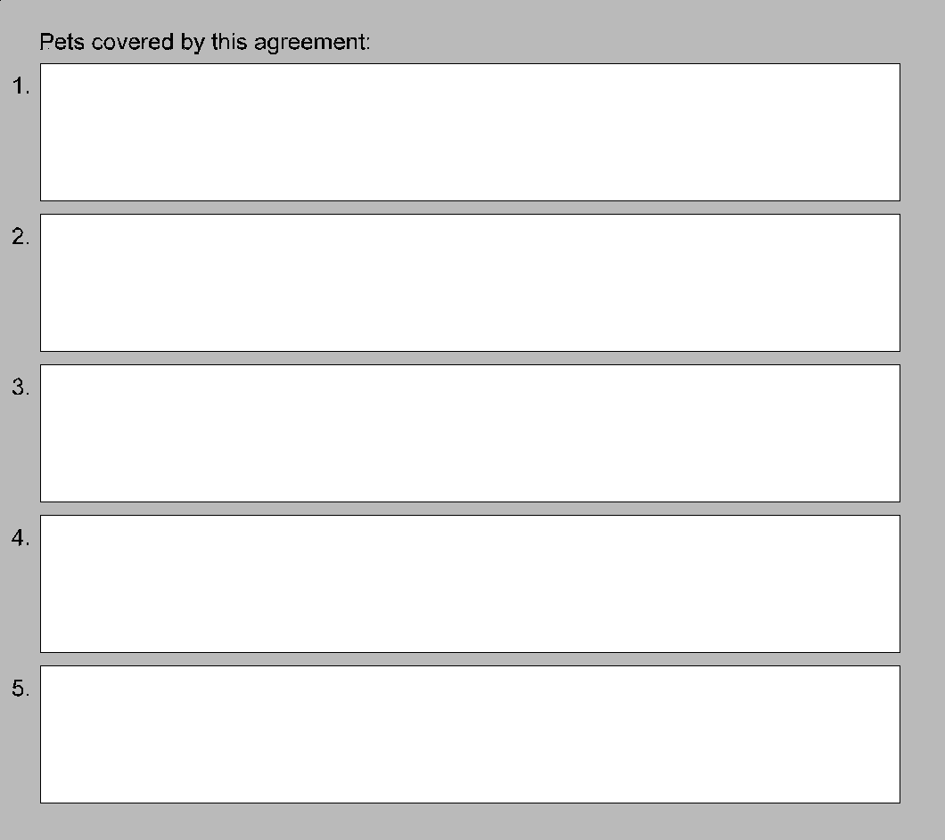

4. Payment for utilities
For an accurate calculation of the house sitter’s liability for utility charges all relevant meter readings should be taken near the start of the house sitting assignment. Before the house sitter leaves the premises at the end of the assignment, further meter readings can be taken and the house sitter’s share of costs can be accurately calculated.

4.1 The home owner agrees to pay or reimburse the house sitter for the following costs:
  - municipal service charges such as council tax and rates
  - all costs incurred by the house sitter in the care of the animals listed in this agreement
  - all costs of emergency repairs or routine maintenance of the premises

4.2 The house sitter agrees to pay service providers directly or reimburse the home owner for the following utilities:
(cross out any of the following that do not apply)
  - electricity
  - gas
  - telephone calls and service charges
  - water
  - excess rubbish or sanitary waste removal charges
  - internet access
  - cable or satellite TV
The house sitter should make good their financial obligations under the terms of this agreement before leaving the home owner’s premises. The house sitter may choose to pay service providers directly and should keep receipts of such payments for home owner’s records. Any financial liability still outstanding at the end of the house sitting assignment may be reclaimed by the home owner from the security deposit.
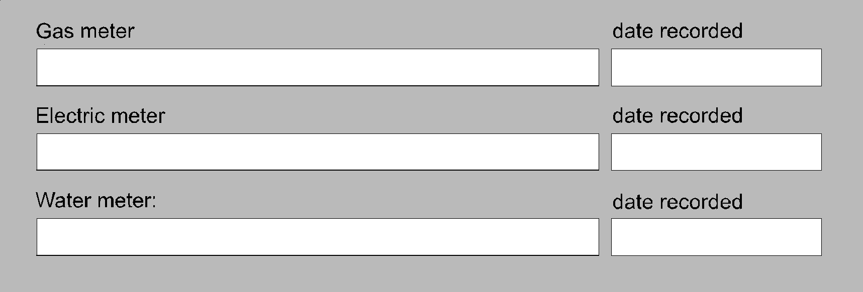

5. Security cameras or recording devices

If there are security cameras or other recording devices on the premises, the home owner should declare this to the house sitter, so that the house sitter can give their consent.

5.1 Home owner declaration
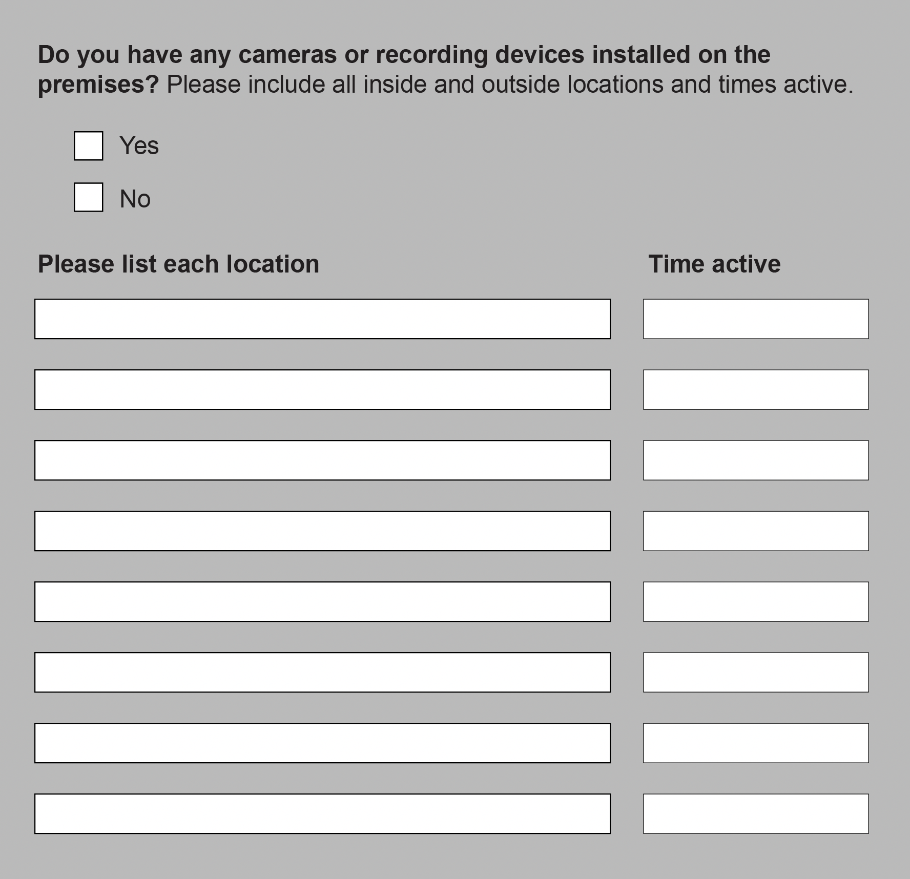

5.2 House sitter declaration

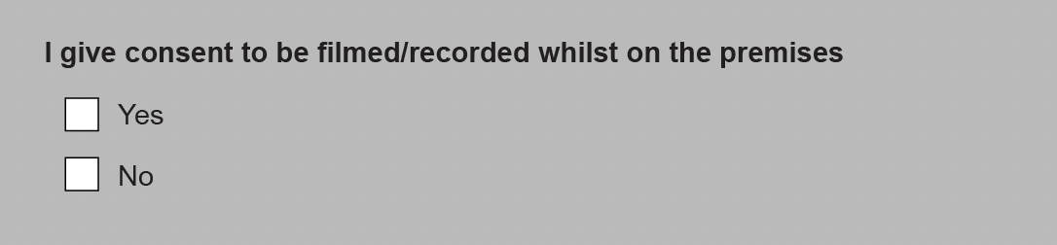

6. Additional terms
Any additional terms and conditions may be added to this agreement here. All parties to this agreement need to initial each additional term. See the ‘Home owners checklist (Appendix B of this agreement) for additional points you may want to address here.


7. Maintenance & repairs

7.1 What are urgent repairs?
The home owner agrees to make payment, either directly to the service provider or as a reimbursement to the house sitter, for the following urgent repairs:
  - burst water service
  - blocked or broken lavatory system
  - serious roof leak
  - gas leak
  - electrical faults
  - flooding or serious flood damage
  - serious storm damage
  - serious fire damage
  - failure or breakdown of the gas, electricity, or water supply to the premises
  - failure or breakdown of any essential service for hot water, cooking, heating, or laundering
  - any fault or damage that causes the premises to be unsafe or not secure

7.2 Repairs & emergency contact details
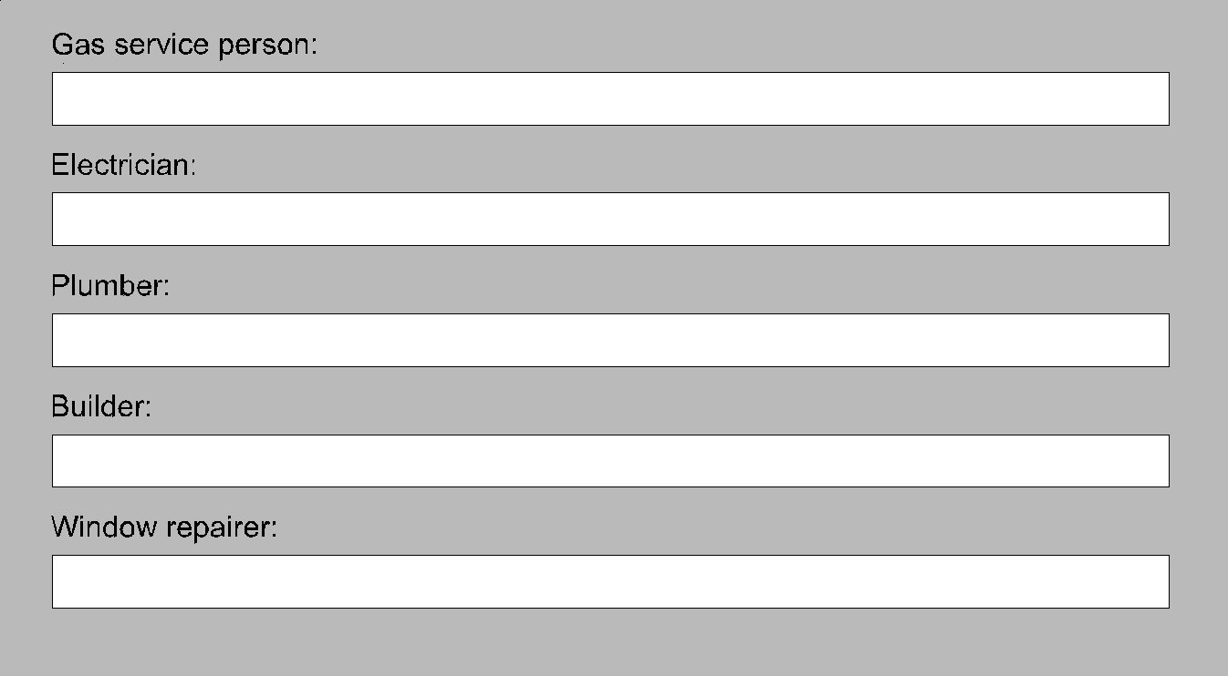

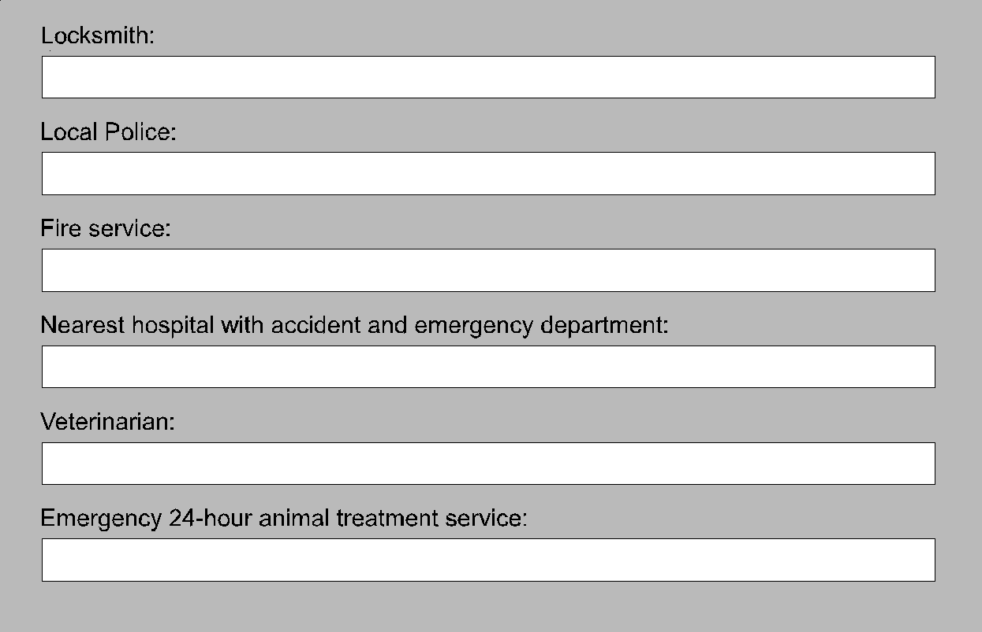

7.3 Reimbursement for repairs
The home owner agrees to pay the house sitter, within 14 days of the end of the house sitting assignment, any reasonable costs that the house sitter has incurred for making repairs to the premises so long as:
  - the house sitter was not in breach of this agreement when the damage occurred
  - the house sitter gives the home owner, or their nominated contact, a reasonable opportunity to make the repairs
  - the house sitter makes a reasonable attempt to have any appropriate tradesperson named in this agreement make the repairs
  - the repairs are carried out, where appropriate, by licensed or properly qualified persons
  - the house sitter gives the home owner, or their nominated contact person, written details of the repairs, including receipts for any costs the house sitter has incurred

8. Staying in contact

8.1 Home owner’s contact details
The home owner agrees to provide the house sitter with contact details for use during the term of this agreement. These contact details, whether phone or fax numbers, postal or email addresses, should remain current and functional during the term of this agreement.
The home owner can be contacted by the following methods during the term of this agreement:


8.2 Nominated contact person’s details
The home owner may choose to nominate a third party to act on their behalf during the term of this agreement. This nominated contact person agrees to provide the house sitter with their contact details and to be readily contactable. Those details should remain current and functional for the term of this agreement.
The home owner’s nominated contact person can be contacted by the following methods during the term of this agreement:

8.3 House sitter’s contact details
The house sitter agrees to provide the home owner or the home owner’s nominated contact person with their contact details and to be readily contactable. These details should remain current and functional for the term of this agreement.
The house sitter can be contacted by the following methods during the term of this agreement:

9. Termination of agreement

9.1 The home owner agrees:
  - to give the house sitter at least seven days notice of an early termination of this agreement if the agreement is for less than six months
  - to give the house sitter at least 28 days notice of an early termination of this agreement if the agreement is for six months or longer

9.2 The house sitter agrees:
  - not to leave the premises before the end of this agreement without written permission from the home owner or nominated contact person
  - to give vacant possession of the premises to the home owner or nominated contact person’s on the date of termination of this agreement
  - to return all keys and other security devices on the date of termination of this agreement
  - to provide the home owner or nominated contact person with a forwarding address
  - at the end of this agreement the house sitter may continue to occupy the premises under the same terms of this agreement only if given permission to do so by the home owner

9.3 Both parties agree:
  - that if either party persistently breaches this agreement, then the innocent party may terminate this agreement on 24 hours notice that termination of this agreement does not affect the right of either party to recover any monies due under the terms of this agreement

10. Signatories & witnesses
The home owner and the house sitter enter into this agreement and agree to all its terms.
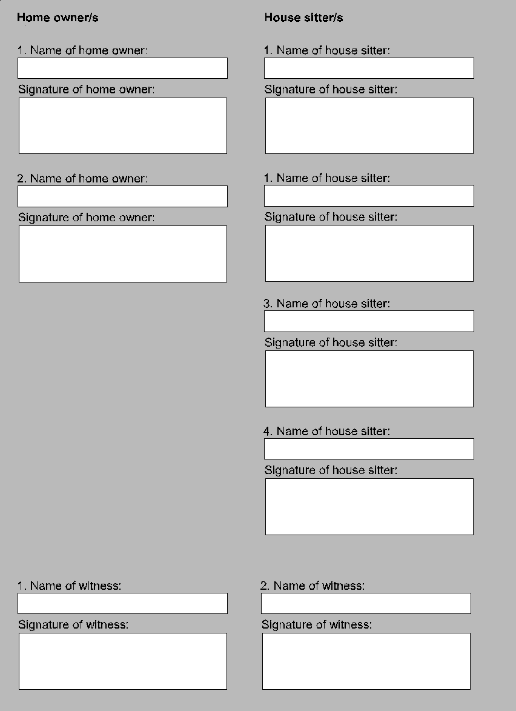

Appendix A

1. Security deposit lodgment form
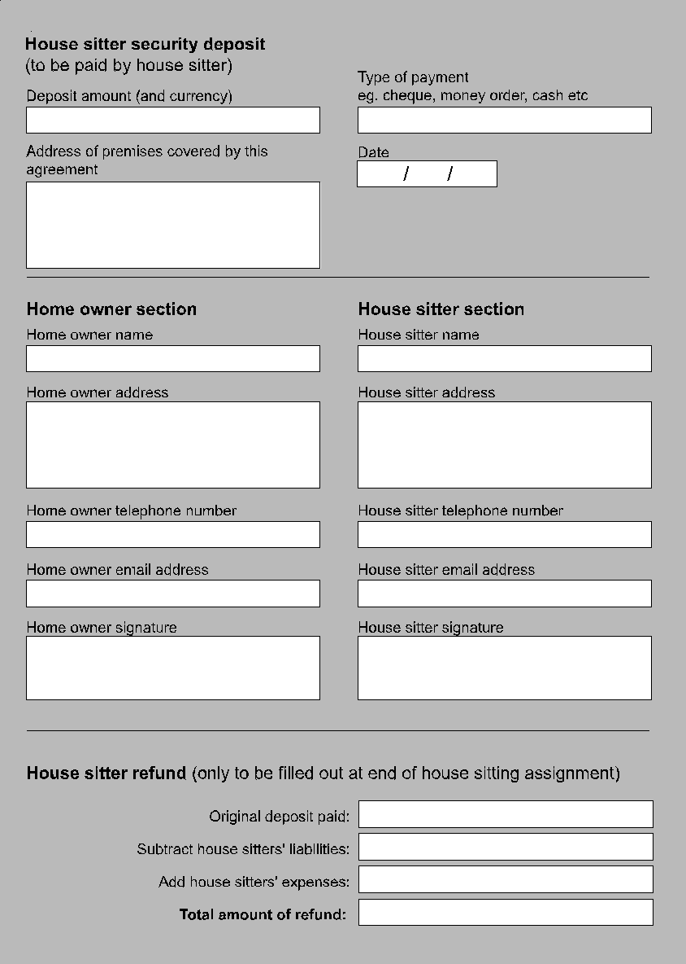1.1 Lodging the security deposit lodgment form with a third party
Use this part of the form if you’re going to be lodging the deposit with a third party for safe keeping. In the event of a dispute between home owner and house sitter at the end of the house sitting assignment the person nominated to hold the deposit agrees to mediate.

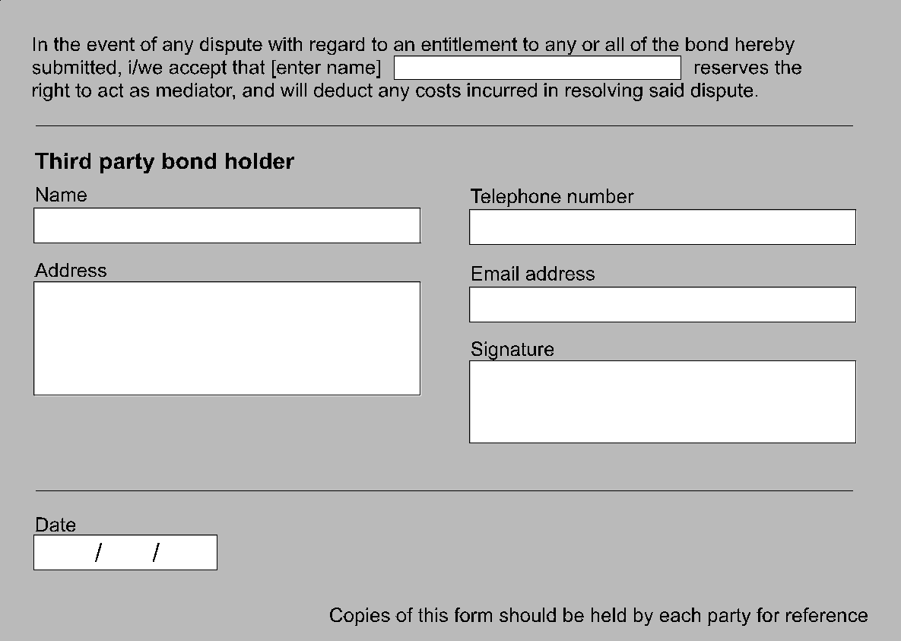2. House sitter expense claims
This form to be used to list the house sitter’s expenses in the care and upkeep of the property and the animals listed in this agreement. The house sitter should keep an itemised list of such expenses as well as a receipt for each item.
Claim for the following costs and purchases:
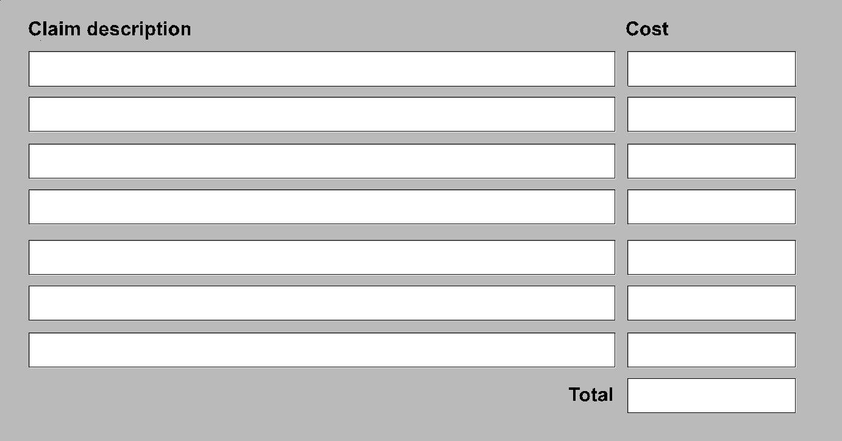

3. House sitter liability claims
This form to be used to list the house sitter’s liabilities during the house sitting assignment. These could include any accidental loss or damages to the home owner’s property.
